ITP : Statistique

Exercice 1 :
Script :
sink("C:\\Users\\eowal\\Desktop\\ITP\\result.txt")

#500 val aléatoires avec la loi Poisson
X = rpois(500,4)
print(X)

#Moyenne
moy = mean(X)
print(moy)

#Variance
variance = var(X)
print(variance)

#Diagramme baton
barplot(X, main="Diagramme baton des 500 valeurs aléatoires")
#la fonction cumulative
fct = ecdf(X)
plot(fct, main="La fonction cumulative des 500 valeurs aléatoires")

#Mediane
med = median(X)
print(med)

print(summary(X))

boxplot(X, main="Boxplot des 500 valeurs aléatoires")

sink()

Sortie :
[1] 3 4 6 6 1 3 2 3 3 2 2 4 10 7 4 2 2 1 3 2 6 2 2 3 6
[26] 6 2 2 6 6 2 3 4 3 4 5 3 5 1 4 2 4 3 3 5 2 3 4 3 2
[51] 7 2 5 4 5 11 3 4 4 3 3 3 1 3 6 3 2 5 4 2 5 5 4 3 3
[76] 4 7 1 9 3 2 5 5 5 6 4 4 4 4 5 3 1 5 2 9 7 2 0 2 2
[101] 1 7 3 3 6 4 0 6 1 2 4 5 3 8 8 5 4 1 4 3 6 2 7 3 1
[126] 4 2 6 2 6 2 2 4 4 4 7 6 8 5 3 6 6 6 6 5 2 1 6 5 4
[151] 4 4 5 2 4 3 7 5 0 3 3 5 6 4 7 2 7 3 5 3 6 1 5 8 4
[176] 2 4 4 6 3 4 3 3 6 3 6 3 3 5 5 9 6 2 2 2 4 4 3 6 4
[201] 0 0 4 4 3 6 3 6 6 4 4 5 4 1 7 3 2 6 5 1 5 3 2 7 0
[226] 5 3 3 3 2 3 5 3 5 4 5 3 4 7 4 1 2 4 2 5 6 3 7 5 2
[251] 8 2 7 1 5 3 2 4 4 8 5 3 3 6 5 3 5 6 4 3 11 3 3 2 4
[276] 2 0 6 4 3 3 2 6 2 4 3 3 5 2 5 3 5 3 3 5 2 6 5 9 2
[301] 2 3 3 6 6 5 5 3 5 4 3 2 3 5 2 5 4 5 4 6 3 3 0 0 3
[326] 5 5 7 5 6 6 4 2 4 3 1 3 3 4 2 6 5 6 5 7 6 6 3 4 1
[351] 4 3 4 3 5 3 10 3 5 3 5 5 5 2 2 4 3 4 3 2 3 2 4 3 6
[376] 2 3 7 2 3 1 6 6 4 4 3 9 4 3 2 7 1 5 7 6 5 6 3 4 5
[401] 5 4 7 3 7 3 6 2 2 6 5 3 2 3 5 5 6 6 3 2 7 6 5 7 6
[426] 4 1 2 7 2 4 1 3 4 1 3 5 6 1 3 6 3 3 7 1 3 3 5 4 4
[451] 7 1 6 5 3 6 4 7 1 3 5 4 6 5 7 9 4 5 3 7 6 1 5 3 3
[476] 2 5 1 7 2 4 6 2 3 3 5 4 7 5 8 2 3 3 5 5 1 3 5 5 6
[1] 4.014
[1] 3.761327
[1] 4
Min. 1st Qu. Median Mean 3rd Qu. Max.
0.000 3.000 4.000 4.014 5.000 11.000
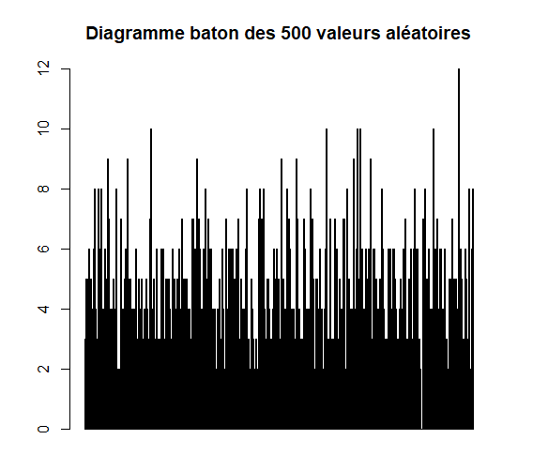
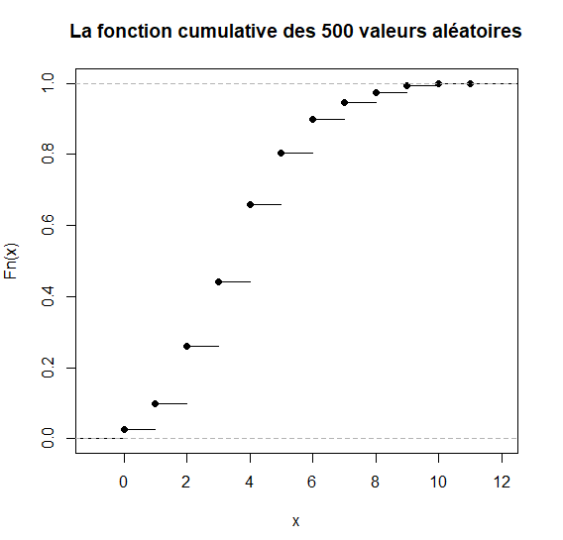

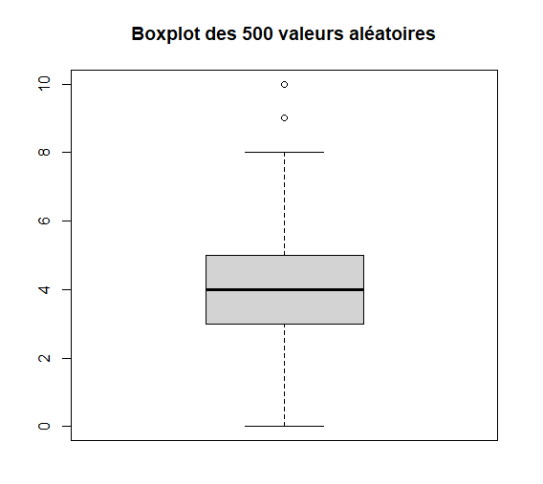

Exercice 2:
Script :
sink("C:\\Users\\eowal\\Desktop\\ITP\\result.txt")

#les 200 valeurs génèrés
X = rnorm(200, 2, 1.5)
print(X)

#Résumé
print(summary(X))

#Histogramme
hist(X,main="Histogramme de la série ",col=rainbow(5))

sink()

Sortie :
[1] 2.87870279 3.60163460 2.34600951 2.15351630 1.59136031 2.55096031
[7] 3.06759642 1.40647561 4.42718774 1.13040576 7.24008291 -0.05289730
[13] 1.11048497 5.19977364 -0.51819859 1.88533902 3.44417467 1.57492449
[19] -0.12188181 0.60790784 2.52571848 0.77012152 2.95403548 0.72281760
[25] 1.84459231 3.12719783 -1.25483790 2.10919097 3.00935681 1.15559778
[31] 2.51104933 2.31392186 2.87441385 2.87890612 1.77952577 4.42264269
[37] 4.23608283 2.36888305 2.09511526 1.46521590 1.77243834 1.91801843
[43] 1.04593569 0.91843979 0.47617496 4.35800359 5.09031599 3.99350902
[49] 1.16202298 0.17135462 0.34174727 -2.07360055 3.17435952 1.90682275
[55] 0.60358382 4.01018495 1.73947772 3.34686827 2.47312214 2.98148544
[61] -2.26380428 -1.19984346 1.32373501 3.52092853 2.38417577 -0.12252535
[67] 0.41129157 -0.52483184 2.10896861 2.98453440 3.82885158 -0.37967465
[73] 3.56524980 1.56322559 0.57793217 0.49245609 3.02770289 0.25089343
[79] 3.77698817 3.00672958 0.30892935 2.20154503 3.15288235 1.05867169
[85] 2.45063436 0.88378302 2.29333731 0.49541869 1.67318243 1.15314920
[91] 1.92061686 3.44318703 3.75432377 3.65121633 0.54855132 3.74980202
[97] 2.11186035 3.86567430 2.97871352 2.26666623 1.27413136 1.27711878
[103] 1.58856485 1.69104168 3.28726554 2.91083382 1.73088910 3.02625313
[109] 1.55182051 5.08867552 2.60406074 2.72023584 4.58341954 2.94507402
[115] 2.80940903 2.25347080 1.32945395 1.70486587 0.12214119 2.58072338
[121] 2.40229779 3.99695345 0.29844424 1.93421080 0.32440272 2.72332430
[127] 0.63919528 0.92175036 4.52086098 2.01186983 3.31690888 1.02436456
[133] 1.52058937 2.50896079 1.54332134 0.85864917 5.42185481 2.79385692
[139] 0.61643556 1.09928721 5.83558306 4.00367513 2.37234260 3.59339111
[145] 2.66497207 1.53819463 3.40009818 1.28584542 2.94208015 1.09782829
[151] 2.55361719 0.90791714 0.48970309 2.50143763 -0.41028727 1.67296191
[157] 1.68208329 1.02169746 0.62231768 0.58243691 2.88192617 0.68282785
[163] 0.98596614 4.10411482 3.37950073 2.82739706 2.73215323 0.56216989
[169] 1.59969881 -0.34279257 3.55214993 2.17296592 2.42902353 0.59336158
[175] 2.54927152 2.61933520 2.15363726 1.93722548 2.35085109 1.50694366
[181] 0.74036446 0.83367423 1.06795406 1.39744238 1.19508966 1.74178212
[187] 0.44229283 2.46743660 0.09239343 -1.04882684 2.61296325 2.38209564
[193] 2.14798240 0.91871381 1.33772202 1.14985936 -0.75410719 3.33491165
[199] 2.05515443 2.48667055
Min. 1st Qu. Median Mean 3rd Qu. Max.
-2.264 1.013 1.975 1.985 2.919 7.240

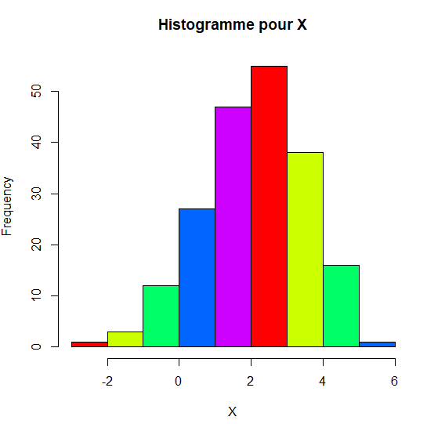

Exercice 3:
Script :
sink("C:\\Users\\eowal\\Desktop\\ITP\\result.txt")

#tableau pour les hommes
print("Hommes")
male=matrix(c(32,11,10,3,53,50,25,15,10,10,7,7,3,30,5,8),byrow=TRUE,ncol=4)
print(male)

#tableau pour les femmes
print("Femmes")
female=matrix(c(36,9,5,2,66,34,29,14,16,7,7,7,4,64,5,8),byrow=TRUE,ncol=4)
print(male)

sink()

Sortie:
[1] "Hommes"
[,1] [,2] [,3] [,4]
[1,] 32 11 10 3
[2,] 53 50 25 15
[3,] 10 10 7 7
[4,] 3 30 5 8
[1] "Femmes"
[,1] [,2] [,3] [,4]
[1,] 32 11 10 3
[2,] 53 50 25 15
[3,] 10 10 7 7
[4,] 3 30 5 8

